
Columbia SWCD Board of Directors Meeting Agenda – March 20, 2024
DATES TO REMEMBER

- 01/20 – Office Closed

- 02/02 – 02/05 NACD Annual Meeting; Anaheim, CA

- 02/07 - 02/09 – SDAO Conference, Seaside

- 02/19 – Board Meeting 7:30 PM
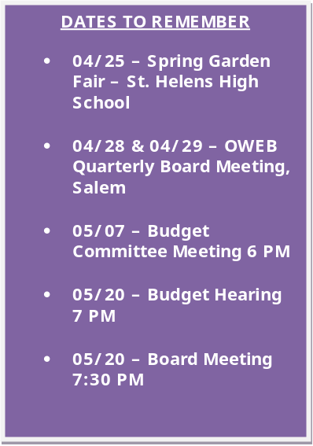

35285 Millard Road
St. Helens, OR
97051
Ph: 503.433.3205

www.columbiaswcd.com
Regular Board Meeting Call to Order – 4:00 PM
DATES TO REMEMBER

- 04/09 – Budget Committee Meeting 5:30 PM

- 04/16 – 04/18/24 – CONNECT 24 Sunriver

- 04/17 – Board Meeting 4:00 PM?

- 05/15 – Budget Hearing 3:30 PM

- 05/15 – Board Meeting 4:00 PM

Approval of meeting minutes – From February 21, 2024
Treasurer’s Report- February 29, 2024
Public Comment – Topics from the Floor
Agenda Items

Reports:
- NRCS
- Watershed Councils
- Staff Reports

Old Business:
- April Board Meeting Date Discuss

- 2024/2025 Work Plan Approve
New Business:
- Updated Salary Chart Approve
- Salary Increases/COLA for Budget Approve
- IT Surplus Approve
- Door Policy Approve
- Contract Approve

Reports:
- Board

Adjourn

